Notice of Public Meeting of the Governing Body of Valor Preparatory Academy
April 15, 2024 @ 10:00 a.m.

Virtual Meeting
Join Zoom Meeting
https://zoom.us/my/valorprep

Pursuant to A.R.S. 38-431.02, notice is hereby given to the members of the Governing Body for Valor Preparatory Academy and the public that Valor Preparatory Academy Governing Body will hold a Governing Body meeting open to the public on April 15, 2024 at 10:00 a.m. at 13185 W. Thomas Road Goodyear, AZ 85395– Meeting to be held virtually.

The Agenda for this meeting is provided below. However, the Governing Body reserves the right to change the order of items of the Agenda except for public hearings set for specific time. One or more members of the Governing Body may participate in the meeting by telephonic communication.

Pursuant to A.R.S. 38-431.03 A.3, the Governing Body may vote to convene an executive session, which will not be open to the public, for discussion or consultation for legal advice with the Governing Body’s attorney on any matter listed on the Agenda. The attorney may participate in person or by telephone.

A copy of the background material for an agenda item provided to the Governing Body members (except for materials relating to executive sessions), is available for public inspection at the meeting location prior to the Governing Body meeting. Please contact Marcy Dube at 623.298.4520 for more information.

Persons requiring a language interpreter or a person with a disability requiring reasonable accommodations to access the Governing Body meeting may submit a request by contacting Marcy Dube at 623.298.4520. Requests should be submitted at least two (2) working days prior to the public meeting to allow time to arrange for the requested service.

Agenda

- Call to Order and Roll Call

- Accept Agenda

- Call to the Public – This is the time for the public to comment. Members of the Governing Body may not discuss items that are not specifically identified on the agenda. Therefore, pursuant to A.R.S 38-431.01 (H), action taken because of public comment will be limited to directing staff to study the matter, responding to any criticism, or scheduling the matter for further consideration and decision at a later date.

- Discussion and possible action to approve the Governing Body Meeting Minutes from March 4th, 2024.

- Discussion and possible action to approve changes to the bylaws regarding number of required governing body members from 5 to 3.

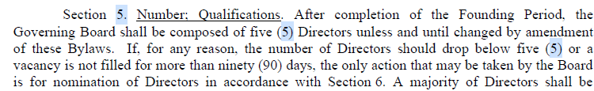

- Discussion and possible action to approve changes to the bylaws requiring committees and offices within the governing body.
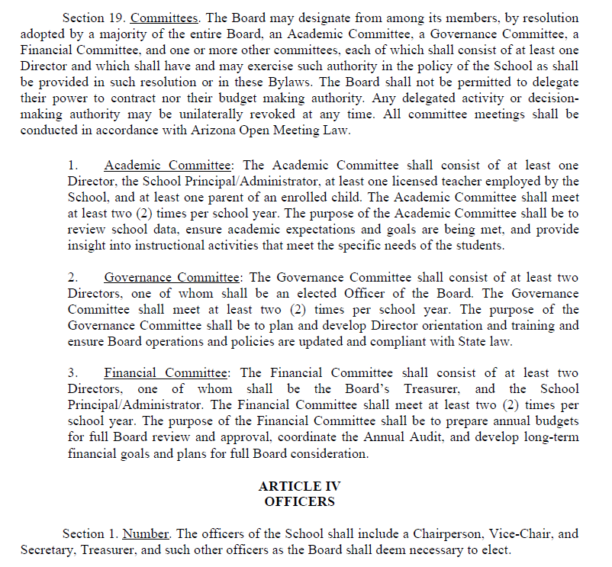

- Discussion and possible action to approve the 2024-2025 student/parent handbook.

- Discussion and possible action to approve 24-25 school calendar.

- Review staffing changes

- Adjournment

Place of Posting: Valor Preparatory Academy 13185 W. Thomas Road Goodyear, AZ 85395

Date/Time of Posting: 4/10/2024 at 4:00 pm. Posted By: Dan Mahlandt

